

**MIT WORLD PEACE UNIVERSITY**

**School of Computer Engineering and Technology**

124, Paud Road, Kothrud, Pune 411038, Maharashtra- India

Project Report

ON

ROAD TRIP ANALYSIS USING GENETIC ALGORITHM

**UNDER THE GUIDANCE OF**

**MRS. KAJAL KHATRI**

BY

AAKASH SUKRE

RAJ DHAMDHERE

SAKSHI KALUNGEPATIL

SANKET WADJE

**Approval of Guide**

Mrs. Kajal Khatri

**INTRODUCTION**

* 1. **Abstract**

One of the Machine Learning Projects which can have an immediate impact on our lives is the Road Trip Analyzer. With our dependence on data and applications nowadays, travelling to unfamiliar places has become the domain of the road trip analyzer.

A reliable Trip-generation Forecasting Model is the most basic part of the traffic forecasting model. The project has been built on the genetic algorithm which has exceptional Global search capability. It will allow the trip-generation forecasting model to improve the accuracy of the prediction. One of the biggest difficulties in planning a road trip is deciding where to stop along the way. The proposed system attempts to match the drivers’ constraint with the fastest route available so that the users have the best of both worlds.

**1.2 Problem Statement**

To develop a system which will provide the road trip plan for the users and make their planning easier and more effective. Finding the shortest route using the most traditional Genetic Algorithm for the journey.

**1.3 Introduction**

Travel and tourism sector play an important role in the world economy. In 2016, the business volume of global tourism surpassed that of oil exports, food products or automobiles. Asia and the Pacific led the tourism sector growth in 2016 with a 9% increase in international arrivals, followed by Africa (8%) and the Americas (3%).

Travelling has been an important etiquette in human life which they constantly enjoy doing. Road Trips are the most common and refreshing thing which people frequently keep organizing. Management of trips have always been considered important for proper execution of the trip. Today technology has been helping us through various ways and letting things go around easily. With the use of Technology, we develop a system which helps in managing the trip by performing core activities and providing substantial output to users and prepare a plan for them.

Basically, our project can be divided into 3 modules which are finding the shortest route, recommending essential stops and preventing dizziness of the driver.

1.3.1 SHORTEST ROUTE

As we know the road trip has the source and the destined location. The main requirement is to calculate the distance between them for the user. As we know there can be multiple routes present but considering the expenditure and time factor, we can save ample amount of it finding the most optimal route i.e. the SHORTEST ROUTE. So, we opted for Genetic Algorithms for this purpose.

Genetic Algorithm is a search heuristic that is inspired by Charles Darwin’s theory of natural evolution. This algorithm reflects the process of natural selection where the fittest individuals are selected for reproduction in order to produce offspring of the next generation.

1.3.2 ESSENTIAL STOPS

Experiencing local food while making a trip has been considered to have a significant impact on tourist satisfaction level. Visiting restaurants has become an integral part of the tourist daily itinerary plan. However, planning an itinerary manually is a complex and time-consuming task.

1.3.3 PREVENTING DIZZINESS

As we are aware of the road accidents and other kinds of harm caused due to lack of presence while driving thought of preventing it. This can be done using the sensor and provide an alert to the driver whenever he seems to be dizzy. This can be implemented using OPEN-CV and IOT.

**1.4 PROJECT ASSUMPTION**

Following parameters can be assumed to obtain optimal results from the Road Trip System:

Weather: It needs to be clean

Route Status: No construction or blockage should occur between the routes

Technical Assumption: System working with minimum to negligible number of deadlocks and less computational latency

Vehicle Status: Vehicle should be maintained properly

**1.5 Project Benefits**

Effective Plan Preparation

Shortest Route Service

Cost Effective

Stops Recommendations

**LITERATURE SURVEY**

Inspirations for this Project

Following are some of the papers which have been referred by us as an Inspiration:

**2.1 Analysis of Route Optimization Based on Genetic Algorithms.**

Author: Z. Tian

Abstract: We present a complete, fully automatic solution based on genetic algorithms for the optimization of discrete product placement and of order picking routes in a warehouse. The solution takes as input the warehouse structure and the list of orders and returns the optimized product placement, which minimizes the sum of the order picking times. The order picking routes are optimized mostly by genetic algorithms with multi-parent crossover operators, but for some cases also permutations and local search methods can be used. The product placement is optimized by another genetic algorithm, where the sum of the lengths of the optimized order picking routes is used as the cost of the given product placement. We present several ideas, which improve and accelerate the optimization, such as the proper number of parents in crossover, the caching procedure, multiple restart and order grouping. In the presented experiments, in comparison with the random product placement and random product picking order, the optimization of order picking routes allowed the decrease of the total order picking times to 54%, optimization of product placement with the basic version of the method allowed to reduce that time to 26% and optimization of product placement with the methods with the improvements, as multiple restart and multi-parent crossover to 21%.

Keywords: warehouse optimization, genetic algorithms, crossover

**2.2 An Improved Genetic Evolutionary Algorithm for Commuter Route Optimization.**

Author: Xiao Hong Qian, Linlin Liu

Abstract: Commuter route problem is a very wide range of intelligent optimization problems in the field of public transport research. Solving route optimization problems is of great significance. Genetic algorithm (GA) is one of the effective methods to solve this kind of problem. The standard genetic algorithm has some limitations. In order to solve the problems that the standard genetic algorithm is easy to be premature and easy to fall into the local optimal solution, an improved genetic evolutionary algorithm(IGEA) is constructed by using adaptive neighborhood method to construct initial population, adaptive crossover mutation probability function and evolutionary reversal etc. to improve standard GA, which improves the quality of the population, enhances the local search ability of genetic algorithm and increases the probability that the offspring will inherit the high quality gene from the father. The simulation results show that the IGEA has better ability to search the optimal solution, the convergence effect is better and the calculation result is more stable.

Keywords: Sociology, Statistics, Genetic algorithms, Optimization, Biological cells, Encoding, Convergence

**2.3 Algorithm selection for classification problems.**

Author: Nitin Pise, Parag Kulkarni

Abstract: A number of algorithms are available in the areas of data mining, machine learning and pattern recognition for solving the same kind of problem. But there is a little guidance for suggesting algorithm to use which gives best results for the problem at hand. This paper shows an approach for solving this problem using meta-learning. The paper uses three types of data characteristics. Simple, information theoretic, and statistical data characteristics are used. Results are generated using nine different algorithms on thirty-eight benchmark datasets from UCI repository. The proposed approach uses K-nearest neighbor algorithm for suggesting the suitable algorithm. Classifier accuracy is taken as a basis for recommending the algorithm. By using meta-learning, accurate method can be recommended as per the given data, and cognitive overload for applying each method, comparing with other methods and then selecting the suitable method for use can be reduced. Thus, it helps in adaptive learning methods. The experimentation shows that predicted accuracies are matching with the actual accuracies for more than 90 % of the benchmark datasets used. Thus, it is concluded that the number of attributes, the number of instances, the number of classes, maximum probability of class and class entropy are playing a major role in classifier accuracy and algorithm selection for thirty-eight datasets used for experimentation.

Keyword: Classification algorithms, Machine learning algorithms, Prediction algorithms, Data mining, Support vector machines, Bagging, Entropy

**2.4 Prediction of Route Choosing Behavior Based on Genetic Algorithm Approach.**

Author: Madalin Dorin Pop, Octavian prostean, Gabriela prostean

Abstract: AI (Artificial Intelligence) became one of the most used concepts in last years. This concept tries to be the foundation of standalone systems that can learn by themselves to adapt to new situations. This adaptation can come only after the system was trained how to behave in several often-encountered situations. The system will be further developed to increase its evolving capacity to deal with new situations related to the learned ones. The purpose of this paper is to show how a GA (Genetic Algorithm), part of AI concept, can be used in traffic route choosing prediction. Our proposed algorithm brings a new approach in fitness function computing, that has a significant role in individuals’ evaluation. The obtained results prove that our proposal gives benefits in computing the destinations volumes and providing them values with a high level of precision.

Keywords: Biological cells, Genetic algorithms, Roads, Encoding, Wheels, Artificial intelligence

# 

# **2.5 Implementation of Detection System for Drowsy Driving Prevention Using Image Recognition and IoT**

Author: [Seo k-Woo Jang](https://sciprofiles.com/profile/author/MWFOZDFSeHlqNFBLSlp2dm52M1VRUVdJVHMwWDlwcFk5QXVpZ1A0SWNjZz0=), [Byeongtae Ahn](https://sciprofiles.com/profile/46523)

Abstract: In recent years, the casualties of traffic accidents caused by driving cars have been gradually increasing. In particular, there are more serious injuries and deaths than minor injuries, and the damage due to major accidents is increasing. In particular, heavy cargo trucks and high-speed bus accidents that occur during driving in the middle of the night have emerged as serious social problems. Therefore, in this study, a drowsiness prevention system was developed to prevent large-scale disasters caused by traffic accidents. In this study, machine learning was applied to predict drowsiness and improve drowsiness prediction using facial recognition technology and eye-blink recognition technology. Additionally, a CO2 sensor chip was used to detect additional drowsiness. Speech recognition technology can also be used to apply Speech to Text (STT), allowing a driver to request their desired music or make a call to avoid drowsiness while driving.

Keywords: drowsy, [driving](https://www.mdpi.com/search?q=driving), [prevention](https://www.mdpi.com/search?q=prevention), [detection](https://www.mdpi.com/search?q=detection), [real-time flicker recognition method](https://www.mdpi.com/search?q=real-time%20flicker%20recognition%20method)

**METHODOLOGY**

**3.1 GENETIC ALGORITHM**

Genetic Algorithms is a widely adapted calculate model, based on natural selection and population genetic mechanism, which was first proposed in 1975 by professor John Holland of the University of Michigan, reflecting the natural selection process of survival of the fittest. By applying a genetic operation to the population to achieve the iterative process of individual structural reorganization within the population, each iteration gets a set of solutions, each of which is evaluated by a fitness function, which repeats until some form of convergence. A new set of solutions not only has the option of retaining some of the old solutions with high fitness values, but also include some new solutions that are combined with other solutions. The three most critical parts are selection, crossover and mutation.

Compared to the traditional search methods and general optimization search methods, genetic algorithms have the following technical characteristics:

1. The genetic algorithm takes the encoding of the object to be processed as the operation object.

2. Genetic algorithms search for multiple solutions simultaneously in search space, which makes the genetic algorithm have a good global search ability.

3. Genetic algorithm search information targeted the fitness function directly.

4. Genetic algorithms use probabilistic search technology to guide the search process.

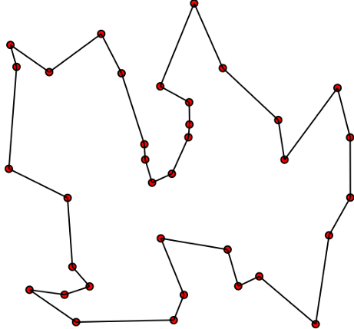

Fig. Illustration of Genetic Algorithm

**3.2 Working**

GA works on a population consisting of some solutions where the population size (pop size) is the number of solutions. Each solution is called individual. Each individual solution has a chromosome. The chromosome is represented as a set of parameters (features) that defines the individual. Each chromosome has a set of genes. Each gene is represented by somehow such as being represented as a string of 0s and 1s as shown in figure 1.

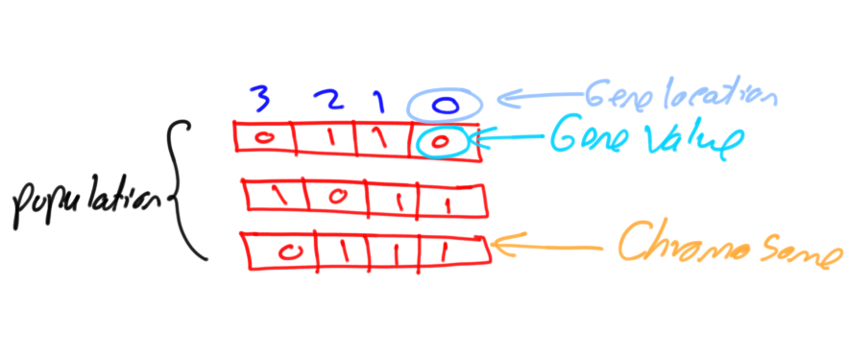

Also, each individual has a fitness value. To select the best individuals, a fitness function is used. The result of the fitness function is the fitness value representing the quality of the solution. The higher the fitness value the higher the quality the solution. Selection of the best individuals based on their quality is applied to generate what is called a mating pool where the higher quality individual has a higher probability of being selected in the mating pool.

The individuals in the mating pool are called parents. Every two parents selected from the mating pool will generate two offspring (children). By just mating high-quality individuals, it is expected to get a better-quality offspring than its parents. This will kill the bad individuals from generating more bad individuals. By keeping selecting and mating high-quality individuals, there will be higher chances to just keep good properties of the individuals and leave out bad ones. Finally, this will end up with the desired optimal or acceptable solution.

**3.3 The Approach**

Basically, we keep the TSP approach using Genetic Algorithm for finding the optimal/shortest route for the trip.

Let’s start with a few definitions, rephrased in the context of the TSP:

* Gene: a city (represented as (x, y) coordinates) Individual (aka “chromosome”): a single route satisfying the conditions above
* Population: a collection of possible routes (i.e., collection of individuals)
* Parents: two routes that are combined to create a new route
* Mating pool: a collection of parents that are used to create our next population (thus creating the next generation of routes)
* Fitness: a function that tells us how good each route is (in our case, how short the distance is)
* Mutation: a way to introduce variation in our population by randomly swapping two cities in a route
* Elitism: a way to carry the best individuals into the next generation

**Drowsiness Detection**

The term “drowsy” is synonymous with sleepy, which simply means an inclination to fall asleep. The stages of sleep can be categorized as awake, non-rapid eye movement sleep (NREM), and rapid eye movement sleep (REM). The second stage, NREM, can be subdivided into the following three stages:

· Stage I: transition from awake to asleep (drowsy)

· Stage II: light sleep

· Stages III: deep sleep

In order to analyze driver drowsiness, researchers have mostly studied Stage I, which is the drowsiness phase. The crashes that occur due to driver drowsiness have a number of characteristics:

· Occur late at night (0:00 am–7:00 am) or during mid-afternoon (2:00 pm–4:00 pm)

· Involve a single vehicle running off the road

· Occur on high-speed roadways

· Driver is often alone

· Driver is often a young male, 16 to 25 years old

· No skid marks or indication of braking

The most commonly used drowsiness scale is the Karolinska Sleepiness Scale (KSS), a nine-point scale

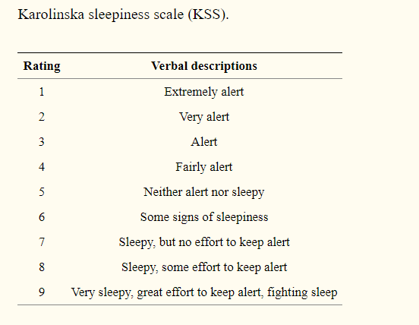

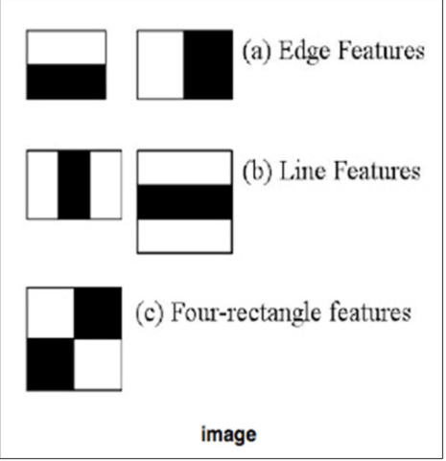

The mean-shift is a method used to find the peak or center of gravity of data distribution, which indicates the algorithm is moving to a data-dense area and the center of the distribution.

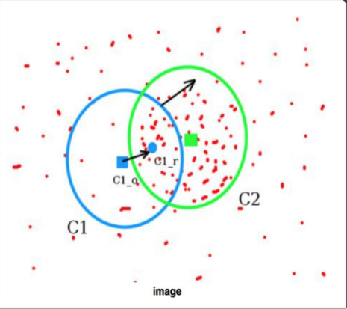

Obtain data originating from the radius, r, from the current position.

Move the current position to the coordinates of the center of gravity.

Repeat step 1 and 2 until the position converges.

OpenCV’s Hough Circle Transform

This method detects pupils in the eye region. The detected pupils are binarized and filtered; all pixels brighter than the threshold are designated as white, and the other areas are designated as black.

**PROJECT REQUIREMENTS**

Following are the requirements for our system:

5.1 SOFTWARE REQUIREMENT

* JavaScript
* React Framework
* Mongo dB
* Python
* Google Maps API

5.2 HARDWARE REQUIREMENT

* Web-Camera
* Windows/Ubuntu Server

Requirements Rationale

|  |  |  |
| --- | --- | --- |
| Sr no | Requirement | Rationale |
| 1 | JavaScript | **JavaScript** (JS) is a lightweight, interpreted, or just-in-time compiled programming language with first-class functions. While it is most well-known as the scripting language for Web pages, it can be used for creating web pages for the system. |
| 2 | React Framework | React is an open-source, front end, JavaScript library for building user interfaces or UI components. It is maintained by Facebook and a community of individual developers and companies. React can be used as a base in the development of single-page or mobile applications for our system. |
| 3 | Python | Python is an interpreted, high-level and general-purpose programming language. Due to availability of inbuilt functionalities we can implement the algorithm using it properly. |

**Interpretation**

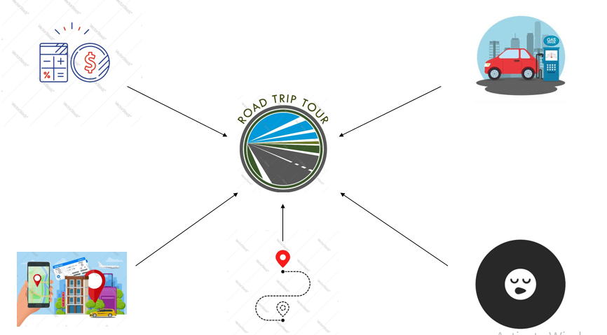

**UML Diagrams**

